
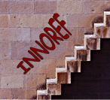

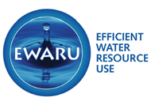
Steering Committee Meeting
MALBORGHETTO (Udine) 9th of June 2006
Palazzo Veneziano

AGENDA
MORNING  9,00  9,30 | - Registration of partecipants  - Appoint SC Secretary for Writing minutes  - Opening and Welcome by Comunita’ Montana Gemonese Rapresentatives
9,45 | - EWARU state of art  Partecipation process: establishment of networks and workshops results  Municipality of Terni LP (Umbria Italia- Italy)  Comunita’ Montana Gemonese (Friuli Venezia Giulia- Italy)
10,45  11,00 | Coffee Break  - EWARU state of art  Partecipation process: establishment of networks and workshops results  Municipality of Etoliko (Greece)  Municipality of Potstat (Czech Republic)
12,00 | - Web site and dissemination activites  Municipality of Potstat (Czech Republic)  - Next Progress Report (outputs, timetable)  Municipality of Terni LP (Umbria Italia- Italy)
13,00  AFTERNOON  14,30 | Lunch  - Financial overview  - Overview on water management system in each participating country including financial management of public resources to build infrastructures
15,30 | Coffee Break
15,45  17,00 | - Future steps  next workshops, activities foreseen in the next six months period, outputs, timetable  - Other points;  - Closing remarks and conclusion

